Gini Coefficients: Measuring Income Inequality
SOURCE: Wikipedia https://en.wikipedia.org/wiki/Gini_coefficient#Countries_by_Gini_Index

Simplified definition: Gini Coefficient = F – U, where F is the percentage of national income earned by high income group and U is the percentage of the population represented by the group. Sample calculation of Gini Coefficients:
- If the richest 20% of the population gets 60% of a country’s household income, the country’s Gini coefficient would be .60 - .20 = .40
- THE CLOSER TO 1, THE MORE INEQUALITY: If the richest 1% gets 99% of the income, the Gini coefficient would be .99 - .01 = .98
- THE CLOSER TO 0, THE MORE EQUALITY: If the richest 20% gets 21% of the income, the Gini coefficient would be .21 - .20 = .01
Examples of Gini Coefficients [from World Bank, most recent data available]: Ukraine .25 India .35 Russia .42
Sweden .27 China .42 Honduras .51
Canada .34 United States .42 South Africa .63

------------------------------------------------------------------------------------------------------------------
Ratio of CEO to Worker Pay
SOURCE: Harvard Business Review
https://hbr.org/2014/09/ceos-get-paid-too-much-according-to-pretty-much-everyone-in-the-world

United States (1965) 20-1 Average pay of S&P 500 Company CEO / Average pay of non-supervisory worker
United States (1995) 123-1
United States (2013) 354-1 $12, 259,894 / $34,645
Austria (2013) 93-1 $4,183,419 / $44,983
UK (2013) 84-1 $3,758,412 / $44,743
Norway (2013) 58-1 $2,551,420 / $43,990
------------------------------------------------------------------------------------------------------------------

Distribution of Household Wealth in United States (2012)
SOURCE: Federal Reserve Survey of Consumer Finances 2013
https://dqydj.com/net-worth-in-the-united-states-zooming-in-on-the-top-centiles/

% OF AMERICA’S % OF AMERICA’S AVERAGE NET WEALTH
HOUSEHOLDS WEALTH OWNED PER HOUSEHOLD

top .1% 16% $31,000,000
(the super-rich)

top 1%, not including the super-rich 48% $8,000,000
(the rich)

84% between poor and rich 36% $2,000,000
(the middle class)

bottom 15% 0% -$1,000
(the poor) (negative net wealth)

(OVER)

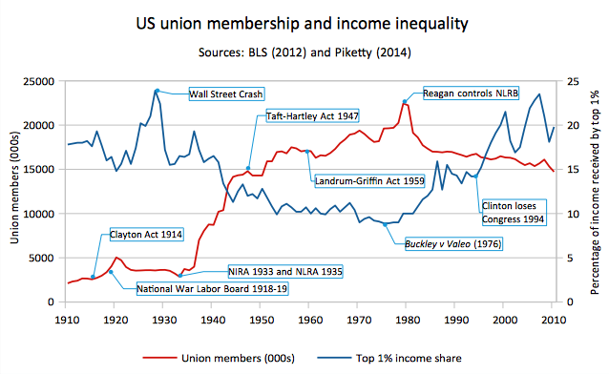
SOURCE: Wikipedia https://en.wikipedia.org/wiki/Labor_unions_in_the_United_States

Capital in the Twenty-First Century by Thomas Piketty (2013)
- Forms of wealth (capital) Forms of Return on Capital
  - Real estate Rent
  - Corporate stock Dividends
  - Bonds and loans Interest
- When average rate of return (r) exceeds rate of economic growth (g), wealth ownership becomes more concentrated.
- r has exceeded g for most of the capitalist era (1790 to present), resulting in increasing concentration of wealth
- Increasing equality between 1930s and 1970s was exception to long term trend. Causes include destruction of inherited wealth by Great Depression and World War II and government policies including support for labor unions and high tax rates on the rich (91% in 1950s vs. 40% today).

Creating an Economy that Works for Everyone
- Progressive global wealth tax of up to 2% per year combined with a progressive income tax up to 80% (Pikkety 2013)
- Single payer health care and free tuition at public colleges and universities (Bernie Sanders)
- Other government policies—see The Middle Class Fights Back (D’Agostino 2012)
  - Green New Deal, including economic conversion of war and fossil fuel economies
  - Convert corporate income tax into worker equity; support worker co-operatives

